Today’s Lecture Road Map
Dated: 29th June 2021
Wire framing
FOOD ORDERING APP
STEP 1: USER FLOW
- Define use cases
- List Activities
- List View Controllers
STEP 2: CONTENT ON THE SCREEN
Individual screen how it looks like
- Sketch core part of User Flow
- What is the purpose of this page?
- How this page helps a user/business achieve its goal(s)?
STEP 3: FIGURE OUT SCREEN RELATIONSHIPS
How screens work together and transit from one to another
- Transitions
- Tab Swap
- Pop up from bottom
- More information from side drawer
STEP 4: PLAN YOUR REVERSE NAVIGATION
- GO BACK TO PREVIOUE SCREEN
- GO TO HOME SCREEN
- APP QUIT
- CANCEL ACTION

Example:

MAIN GOAL: FOOD ORDER
Flow:
Sign In -> Home screen -> Restaurants/Food Places -> Food -> Cart -> Payment -> Confirm Order

A rough draft of Home Screen:

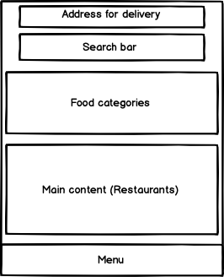
Wire framing: Strive to create mid-fidelity wireframes. Mid-fidelity wireframes are very useful during discussions with the other designers and developers.
- Start with the device with a middle screen size.
- In the early stages create a clear visual hierarchy, set layout and structure. Don’t focus on the content itself, just think about the presentation.
- Plan the layout according to how you want your user to process the information and start by drawing boxes on the canvas.
- Put a strong focus on the order of information you want to present to your users.
- People scan webpages and phone screens from top to bottom, from left to right i.e. (F-shaped pattern works both for desktop and mobile screens).
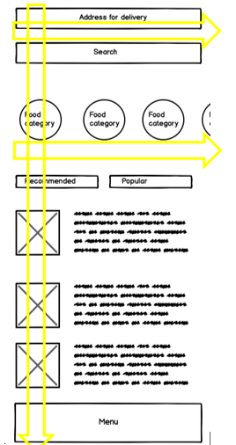

- Familiarity is one of the most important properties of good UX design. When people see familiar UI elements in a new product, they can rely on their previous experience when interacting with this product
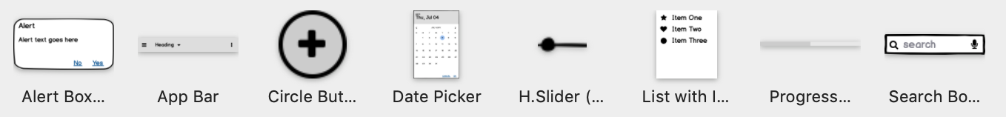

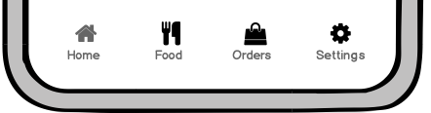
NOW BRING IN THE ACTUAL COPY
- After you are satisfied with your visual hierarchy, start replacing placeholders and dummy text with real content

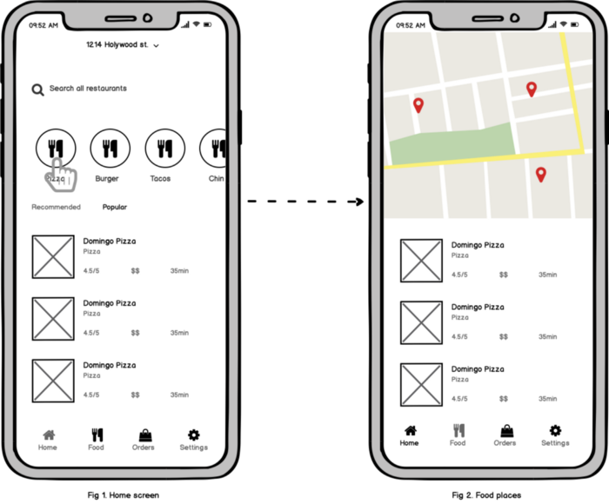

https://balsamiq.com/learn/articles/mobile-app-wireframing-guide/
Case Study: https://uxplanet.org/food-delivery-app-case-study-27d6c7ca8add

